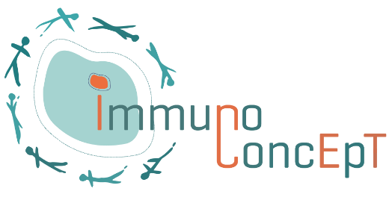

**Post-Doctoral position in**

**Bioinformatics**



**A postdoctoral position in Onco-Immunology and Bioinformatics** is available in the team “Immunology of cancer and inflammatory diseases” under the supervision of Dr. Maya Saleh and at the Bordeaux Bioinformatics Center under the supervision of Dr. Macha Nikolski. *(*[*https://immunoconcept.cnrs.fr/immunology-of-cancer-and-inflammatory-diseases/*](https://immunoconcept.cnrs.fr/immunology-of-cancer-and-inflammatory-diseases/)*)*

**Start and Duration of the appointment:** Start January 2023, the project is an INCA-PLBIO-funded project for 4 years. Contract 1 year renewable for up to 4 years.

**Research context and project:** Glioblastoma (GB) are the deadliest tumors in adults. Despite being part of the current standard of care, surgical resection that fails to eliminate infiltrative GB cells, elicits an inflammatory and immunosuppressive trauma with a potential to promote recurrence. However, the diversity of immune cells in GB post-resection and which specific pathways drive their functions in GB recurrence post-resection remain largely unknown. Our consortium has developed unique genetic murine models to interrogate these questions, and we have access to patient samples for validation. We will use multi-omics approaches (single cell, spatial transcriptomics, spatial metabolomics, and proteomics) to characterize the immune and metabolic landscapes of GB post-resection. We expect that our clinically relevant study will allow a better understanding of the diversity, dynamics, and molecular characteristics of immune cells and their interactions with tumor and stromal cells towards the identification of new therapeutic targets.

**Candidate qualification and selection criteria:** We seek highly motivated and enthusiastic

postdoctoral fellows, able to work independently with excellent communication skills. Applicants should have a Ph.D. in immunology or cancer biology, with a strong background in bioinformatics, and at least one first-author publication in a top-tier journal. Knowledge of single cell and image analyses is an asset.

Criteria to evaluate candidates will include academic achievements, past research experience, interest in working in a multidisciplinary research environment, enthusiasm, communication skills and demonstration of computational skills.

**Application:** Candidates should send their application including CV, a brief description of research accomplishments, list of publications, cover letter and contact for at least two referees into a single PDF file to [maya.saleh@mac.com](mailto:maya.saleh@mac.com) and [macha.nikolski@u-bordeaux.fr](mailto:macha.nikolski@u-bordeaux.fr). Selected candidates will be contacted for an interview. Please submit your application by January 30, 2023. Late applications will be considered until the position is filled.